
NZQA Approved

Internal Assessment Resource
Mathematics and Statistics Level 1
EXPIRED
This resource supports assessment against:
Achievement Standard 91032 version 3
Apply right-angled triangles in solving measurement problems
Resource title: Ramp it up
3 credits
This resource:
- Clarifies the requirements of the standard
- Supports good assessment practice
- Should be subjected to the school’s usual assessment quality assurance process
- Should be modified to make the context relevant to students in their school environment and ensure that submitted evidence is authentic

Date version published by Ministry of Education | February 2015 Version 2  To support internal assessment from 2015
Quality assurance status | These materials have been quality assured by NZQA. NZQA Approved number A-A-02-2015-91032-02-4536
Authenticity of evidence | Teachers must manage authenticity for any assessment from a public source, because students may have access to the assessment schedule or student exemplar material.  Using this assessment resource without modification may mean that students’ work is not authentic. The teacher may need to change figures, measurements or data sources or set a different context or topic to be investigated or a different text to read or perform.
Internal Assessment Resource
Achievement Standard Mathematics and Statistics 91032: Apply right-angled triangles in solving measurement problems
Resource reference: Mathematics and Statistics 1.7C v2
Resource title: Ramp it up
Credits: 3
Teacher guidelines
The following guidelines are supplied to enable teachers to carry out valid and consistent assessment using this internal assessment resource.
Teachers need to be very familiar with the outcome being assessed by Achievement Standard Mathematics and Statistics 91032. The achievement criteria and the explanatory notes contain information, definitions, and requirements that are crucial when interpreting the Standard and assessing students against it.
Context/setting
This activity involves wheelchair ramps at school. Students take measurements and use them to find various lengths and angles.
If your school does not have a suitable ramp students could measure a ramp in another setting, for example, at a museum, hospital, council office, hall, library, or other community facility.
Ensure that students read and understand the attached Resource – an extract from the New Zealand Building Code (NZBC) – before taking any measurements.
Conditions
Students may work in pairs during Session 1 to take and record measurements. They will then work individually in Session 2 to complete the required calculations.
They may use any appropriate technology.
Resource requirements
A tape measure.
Internal Assessment Resource
Achievement Standard Mathematics and Statistics 91032: Apply right-angled triangles in solving measurement problems
Resource reference: Mathematics and Statistics 1.7C v2
Resource title: Ramp it up
Credits: 3
Achievement | Achievement with Merit | Achievement with Excellence
Apply right-angled triangles in solving measurement problems. | Apply right-angled triangles, using relational thinking, in solving measurement problems | Apply right-angled triangles, using extended abstract thinking, in solving measurement problems.
Student instructions
Introduction
Almost all modern buildings have wheelchair ramps. These ramps must meet the requirements specified in the New Zealand Building Code (NZBC) (see attached Resource).
This assessment activity requires you to verify whether a selected ramp in your school complies with these specifications and to consider the rise, run, and length of future ramps.
Note that in this activity the length of a ramp is the total distance the wheelchair travels (including landings), not the ramp’s horizontal length (known as the run). The rise of a ramp is its total gain in vertical height (from bottom to top).
This diagram shows these different terms and how they are used:
You will be assessed on the quality of your discussion and reasoning and how well you link this to the context.
Task
Session 1
- Select a wheelchair ramp in your school that is no higher than 750 mm above ground level. With the help of a classmate, take measurements that will allow you to calculate dimensions and angles in this ramp.
- Identify a building that has an entrance that is more than 750 mm above ground level and does not have a ramp (not wheelchair accessible). The school is planning to install a ramp here and it must meet the required specifications. Take measurements that will allow you to calculate dimensions and angles in this ramp.
Session 2
Refer to the accompanying Resource from the NZBC:
- Confirm whether the existing ramp you selected and measured meets the slope requirements of the NZBC.
- Sketch a possible ramp for the entrance to the building that you have identified, which has an entrance that is more than 750 mm above ground level and does not have a ramp (not wheelchair accessible). Calculate and label relevant lengths and angles. Show that your ramp will comply with the NZBC. Include the total length of handrail that will be required (see the Resource for details).
- The school intends to provide ramps for other school entrances that are not wheelchair accessible. The manager of the building company would like an easy-to-use method that will enable them to calculate the ‘run’ (length on the ground) for any ramp. Develop a suitable method, explaining clearly how the building manager should use it.
Use appropriate mathematical statements to communicate your findings. Include relevant calculations and/or diagrams.
Resource
The diagram shows the requirements for a wheelchair ramp as specified in the NZBC.
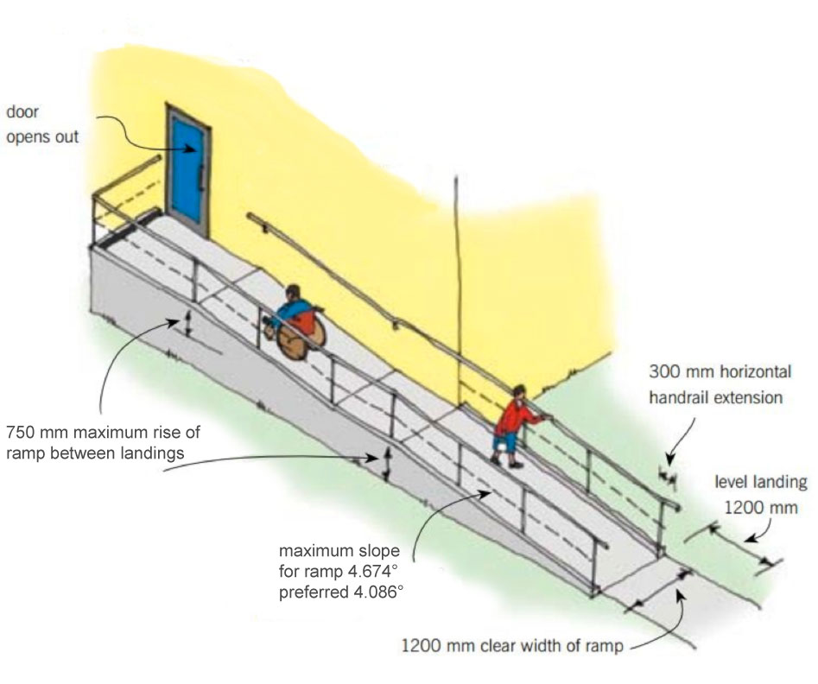
© BUILD December 2007/January 2008

The ramp must be 1200 mm wide. A level landing (1200 mm in length) is required at the top and bottom. The rise between landings cannot exceed 750 mm.

Assessment schedule: Mathematics and Statistics 91032 Ramp it up
Evidence/Judgements for Achievement | Evidence/Judgements for Achievement with Merit | Evidence/Judgements for Achievement with Excellence
Applying right-angled triangles in solving measurement problems will involve:  - selecting and using a range of methods in solving problems  - demonstrating knowledge of measurement and geometric concepts and terms  - communicating solutions that usually require one or two steps.  At least three different methods need to be selected and correctly used in solving problems.  For example, the student:  - takes site measurements at an appropriate level of precision  - uses trigonometry to calculate the slope of an existing ramp  - uses trigonometry to confirm that the existing ramp meets the NZBC specifications  - uses trigonometry to calculate angles and lengths for a proposed ramp.  The student has communicated what is being calculated at each step. | Applying right-angled triangles, using relational thinking, in solving measurement problems will involve one or more of:  - selecting and carrying out a logical sequence of steps  - connecting different concepts and representations  - demonstrating understanding of concepts  and also relating findings to the context, or communicating thinking using appropriate mathematical statements.  The student takes appropriate measurements that will allow the calculation of the dimensions and angles in the ramp, and then uses these dimensions to determine if the existing ramp meets the NZBC specifications.  The student has taken and used appropriate measurements to design a suitable ramp for the identified building and made connections between the ramp length and the handrail length.  The student may have attempted to design a generalisation.  The student has clearly shown a logical sequence of steps and has communicated using appropriate mathematical statements. | Applying right-angled triangles, using extended abstract thinking, in solving measurement problems will involve one or more of:  - devising a strategy to investigate or solve a problem  - identifying relevant concepts in context  - developing a chain of logical reasoning  and also using correct mathematical statements, or communicating mathematical insight.  The student confirms that the existing ramp meets NZBC specifications. They have designed a suitable ramp for the identified building, with landings as required by the NZBC including the total length of handrail needed, and devised an appropriate generalisation.  The student has clearly communicated their solution using correct mathematical statements.
Final grades will be decided using professional judgement based on a holistic examination of the evidence provided against the criteria in the Achievement Standard.

